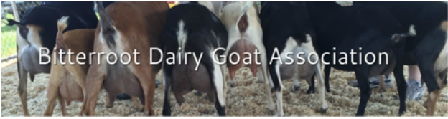
MEMBERSHIP APPLICATION
Name: _________________________________________________________________
Farm Name: ________________________________________________________________
Address: _________________________________________________________________
City:_________________ State_________ Zip _______________________
Phone number:__________________________________ Landline________Cell_____
Email: _____________________________________________Facebook User Yes/No
Website ____________________________________________________________________
Preferred method to contact you: email/text/phone/Facebook/messenger
Goat Breed(s)______________________________________________________________
Membership: Yearly Membership Fee: $25_______Youth Fee: $5 _________
Membership Year Starts January 1 through December 31. Dues should be paid by the end of December for the following year.
Would you like your breeder contact information or web page listed on our Website: Yes_____ No_____
Mail or email entry form to:
Bitterroot Dairy Goat Association-Treasurer
2334 Betty Lane
Victor, MT 59875
bitterrootdairygoatassociation@gmail.com
Payments accepted through Paypal-bitterrootdairygoatassociation@gmail.com or check mailed to the Treasurer

